COLONEL WILLIAM C. WAYNICK II

Colonel William C Waynick II is the Director of Air Force CyberWorx where he leads a cross functional team of the best and brightest subject matter experts from the military, civil service, industry and academia in accelerating disruption and transformation using Cyber to increase multi-domain warfighter effectiveness. The CyberWorx team utilizes innovative industry best practice tools and methodologies with 100% focus on user needs and experience. Facilitating discovery of the root problem and ideation of potential solutions, the CyberWorx team continues to work with the user and the sustaining organization to transition a Minimum Viable Product for iteration and fielding.  Col Waynick entered the Air Force after graduating from the University of Arizona in 1991 as a Distinguished Graduate from ROTC. Colonel Waynick’s career has included a wide range of assignments from computer programming to tactical and airborne communications and SOF support. He has significant experience in combat throughout the Middle East and Africa. | 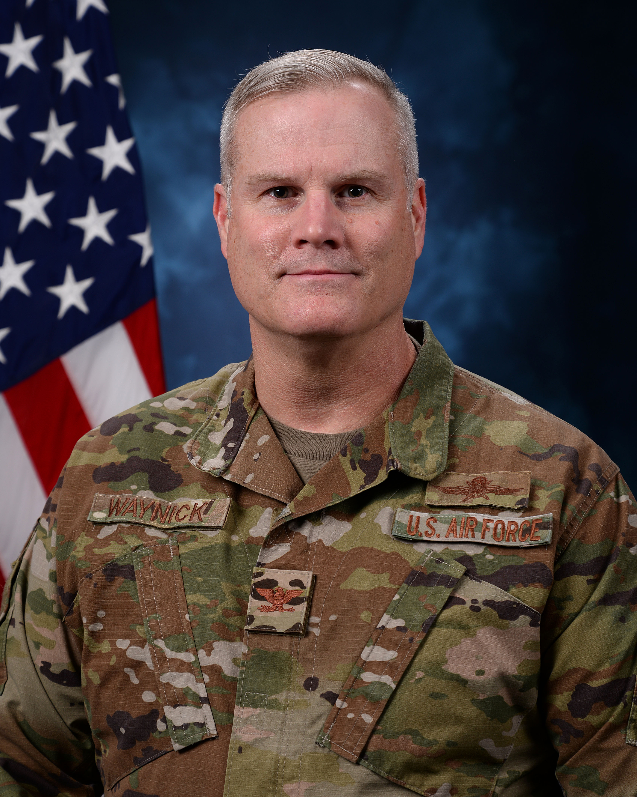

EDUCATION
1991 | Bachelor of Science Degree in Management Information Systems, University of Arizona
1992 | Basic Communication Officer Training, Keesler AFB, MS
1997 | Master of Science degree in Computer Information Systems, University of Phoenix
1998 | Squadron Officer School, Maxwell AFB, AL
2001 | Advanced Communications Officer Training, Keesler AFB, MS
2003 | Air Command and Staff College, by correspondence
2005 | Master's degree of Military Operational Air & Science, Air Command and Staff College, Maxwell AFB, AL
2007 | Air War College, by correspondence
2012 | Master's degree in Strategic Studies, Air War College, Maxwell AFB, AL

ASSIGNMENTS
1. | January 1992 – July 1992, Student, Basic Communications Officer Training, Keesler AFB, MS
2. | August 1992 – December 1994, Theater Battle Management Systems Engineer and WWMCCS Computer Systems Management Officer, 1912th Computer Systems Group, Langley AFB, VA
3. | December 1994 – March 1997, Chief, Software Development and Operations Group Network Project Manager, 355th Operations Support Squadron, Davis-Monthan AFB, AZ
4. | March 1997 – May 1998, Commander, Information Systems Flight, 355th Communications Squadron, Davis-Monthan AFB, AZ
5. | May 1998 – May 1999, Executive Officer, 46th Logistics Group, Eglin AFB, FL
6. | May 1999 – August 2001, Flight Commander, 728th Air Control Squadron, Eglin AFB, FL
7. | August 2001 – August 2004, Chief, NATO AWACS C2 Systems Logistics, NATO AWACS Programme Management Agency, Brunssum, The Netherlands
8. | August 2004 – June 2005, Student Air Command & Staff College, Maxwell AFB, AL
9. | June 2005 – June 2008, Director, C4I, Aviation Tactics Evaluation Group, Fort Bragg, NC
10. | Jun 2008 – June 2010, Commander, 1st Combat Communications Squadron, Ramstein AB, Germany
11. | July 2010 – July 2011, Chief, C4I, Aviation Tactics Evaluation Group, Maxwell AFB, AL
12. | July 2011 – May 2012, SDE Student, Air War College
13. | June 2012 – July 2014, Commander, 5th Combat Communications Group, Robins AFB, GA
14. | July 2014 – August 2017, Director, for Command, Control, Communications and Computer (C4) Systems, Headquarters, Joint Special Operations Command, Fort Bragg, North Carolina
15. | August 2017 – July 2019, Founder/Director, Enterprise IT as a Service Functional Management Office & Air Force Space Command CIO/CISO, Peterson AFB, CO

MAJOR AWARDS AND DECORATIONS
Defense Superior Service Medal
Legion of Merit
Bronze Star Medal with one oak leaf cluster
Defense Meritorious Service Medal with one oak leaf cluster
Meritorious Service Medal with two oak leaf clusters
Air Force Commendation Medal with oak leaf cluster
Air Medal
Joint Service Commendation Medal
Air Force Commendation Medal with two oak leaf clusters
Joint Service Achievement Medal
Air Force Achievement Medal with four oak leaf clusters

EFFECTIVE DATES OF PROMOTION
Second Lieutenant | May 1991
First Lieutenant | Sep 1993
Captain | Sep 1995
Major | Jul 2002
Lieutenant Colonel | Jun 2007
Colonel | Jun 2012

(Current as of March 2021)

